Article Preparation Instructions ver. 2021
J. Novák,¹* L. Skočdopole¹ and B. B. King²
¹ Department of Rockets, Military Academy, Hranice, Czech Republic
² Saint Barbara’s Institute, University of Artillery, Verdun, France
The manuscript was received on DD. MM. YYYY and was accepted
after revision for publication as _____ on DD. MM. YYYY.
Abstract:
Abstract text, abstract text, abstract text, abstract text, abstract text, abstract text, abstract text, abstract text, abstract text, abstract text, abstract text, abstract text, abstract text, abstract text, abstract text, abstract text, abstract text, abstract text, abstract text, abstract text, abstract text.
Keywords:
format instructions, grammar, article preparation, article submission, spelling
- Introduction
In order to ensure common standard layout of the articles included in the AiMT Journal, standardized organization and formatting are defined in these instructions. The person who prepares the article has to comply with the format instructions. The document you are reading has been prepared using these instructions and may be used as a template for article preparation.
If you have any questions concerning the format rules, please contact the Editor of the AiMT Journal, who will be pleased to help you (aimt@unob.cz). Your article is required to be submitted electronically. To satisfy AiMT Journal requirements, every article must be prepared using Microsoft WORD software; LaTeX alternatively. The most recent version of WORD available to you is preferred. Times New Roman font is to be used throughout the article.
All tables, figures, diagrams, and photos should be embedded in your document. Articles should not exceed 16 pages in length. This includes tables and figures, appendices if any, as well as the required references. In order minimize the time for article processing and to expedite printing; therefore, electronic submission of articles using the online editorial system is strongly recommended. The final version of the article should be checked for grammar, spelling, and typographical errors.
- Format and Composition
The page dimensions are defined for ordinary 17.6 × 25.0 cm article B5 (ISO). Margins are set using “Page Setup” in the “File” pull-down menu (see Fig. 1). In the “Multiple pages” list, select “Mirror margins”.
- The top margin is 2.5 cm.
- The bottom margin is 2.5 cm.
- The outside margin is 2.3 cm.
- The inside margin is 2.7 cm.
There is a special header for the first page with journal logo (matter of the editor) and different headers for odd and even pages (see Fig. 2). The footnote is only on the first page with contact information on the corresponding author. Avoid footnotes usage in your article.
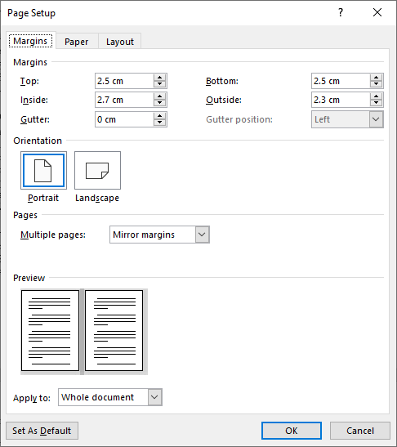
Fig. 1 Page layout setup
- Language Requirements
Authors are kindly requested to submit their articles in English. Please make sure that your article has been thoroughly proofread and meets the requirements for clarity and linguistic and stylistic correctness. It is highly recommended to submit the article in British English. However, submissions in American English also are accepted, provided that the variety of English (spelling), be it British or American, is used throughout the article consistently.
If the level of English clarity and correctness is not on the required level, authors will be asked to have their article proofread. In order to expedite the review and approval process, authors are recommended to ensure the language correctness before submission.
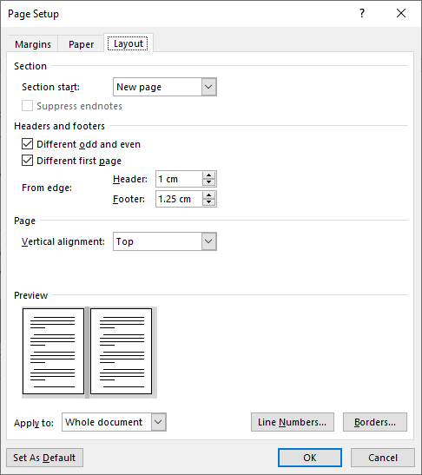
Fig. 2 Headers setup
- Headings and Text
  - Article Title
For the title of your article, use AiMT Title style with the following instructions:
- The title is centred on the page, 4 cm down from the top margin.
- Capitalize the first letter of each word (excluding articles, prepositions and conjunctions); use lower case for the remainder of the word. NOT ALL CAPS, please.
- DO NOT USE BOLD or ITALICS.
- The title is limited to a maximum of two lines.
  - Balance of Title Block
Author line – AiMT Author style. No author’s degree(s) is (are) presented there.
Affiliation line(s) – AiMT Affiliation style. Use the company or institution name by which the employer is generally known in the following order: Institution, City, and Country. Information on the corresponding author is put in footnote.
Acceptance information line – AiMT Affiliation style (acceptance information is a matter of the editor).
The legend “Abstract” – AiMT Abstract style.
Abstract – AiMT Abstract Text style. The abstract should contain 80-120 words and it should summarize the purpose, methods, scope, results, and conclusions of the article.
The legend “Keywords” – AiMT Keywords style.
Keywords – AiMT Abstract Keywords text style. Try to limit the number of key words to five or six.
  - Headings within Article
Capitalize the first letter of each word (excluding articles, prepositions and conjunctions); use lower case for the remainder of the word in all headings. It is strongly recommended that only two levels of headings be used. All headings are single spacing. All headings (level 1 + 2) are automatically numbered – AiMT Heading 1 style, and AiMT Headings 2 style.
The References and Acknowledgment headings are similar to major headings but are not numbered – AiMT Ref & Ack Heading Style.
  - Text
The first line of each paragraph is indented by 0.75 cm – AiMT Normal style, excluding the first paragraph after heading – AiMT Normal Continue style. Do not leave blank line(s) between paragraphs.
- Illustrations
The person preparing the manuscript is responsible for the effective integration of supporting graphics, tables, and other media into the text. All illustrations should be provided in camera-ready form, suitable for reproduction. Here are some additional points:
- Graphics should be embedded in your document.
- Place a caption at the bottom of each object. In the case of tables, put a caption above the table – AiMT Caption style.
- All illustration captions are numbered consequently.
- Make sure that any text in the graphic has a minimum point size of 6 points and in tables has a minimum point size of 8 points. Text below the minimum point size will not be readable in print.
- If a reference to a figure is used in the text, use “Fig.” before its number (for example: “for the headers setup see Fig. 3” or “equations styles are presented in Fig. 4). Similarly, use “Tab.” before a number of the table (for example: “For survey of the journal styles, see Tab. 2”) and “Eq.” before a number of the equation (for example: “All the quantities in Eq. (1) are …”).
- Abbreviations and Acronyms
If abbreviations and acronyms are used in the text they should be defined in the text at first mention and used consistently thereafter. Abbreviation and acronyms should be written in full the first time with the abbreviation in brackets, for example “Probability Density Function (PDF)” or “Standardization Agreement (STANAG)”.
- Symbols of Quantities and Units
Symbols of quantities [1, 2] should be written in italics (scalars, e.g. mass m), in bold italics (vectors, e.g. velocity v) and in bold italics without serifs (tensors, e.g. moment of inertia J). Components of vectors and tensors should be written, as well as scalars (v_{x}, J_{xx}). Sub/superscripts are written in roman (upright) types if descriptive (in C_{g} g means gas) or digit, and in italics if representing quantities (in C_{p} p means constant pressure) or variables.
All measurements and data should be given in SI units, or if SI unit does not exist, in an internationally accepted unit [1]. Symbols of units are written in roman types. A compound unit formed by multiplication of two or more units shall be indicated in one of the following ways: N · m, N m (the latter form is preferred), not N.m. Also way Nm can be accepted – provided that special care is taken when the symbol for one of the units is the same as the symbol for a prefix (m, metre and milli, or T, tesla and tera). A compound unit formed by dividing one unit by another shall be indicated in one of the following ways: m/s (without spaces – preferred), m · s⁻¹, m s⁻¹ (minus sign should be used, not hyphen). A solidus (/) shall not be followed by a multiplication sign or a division sign on the same line unless parentheses are inserted to avoid any ambiguity, e.g. J/(kg·K). In complicated cases, negative powers may be used.
Spaces must separate numbers from symbols of units (5 m, 12 m/s or 12 m ⋅ s^{–1}, 15 °C, 56 %). The only exceptions to this rule are for the units degree, minute and second for plane angle, in which case there shall be no space between the numerical value and the unit symbol (12°32’55.3”). Ranges and tolerances shall be indicated in an unambiguous manner: 10 m to 12 m (not 10 to 12 m), (23 ± 2) °C or 23 °C ± 2 °C (not 23 ± 2 °C). Do not use non-standardized abbreviations for units, e.g.:
- for seconds use s, not sec or secs,
- for micrometres use μm, not microns,
- for cubic centimetres use cm³, not cc or ccm,
- for minutes use min, not mins,
- for hours use h, not hrs,
- for km per h use km/h or km h^{–1} or km · h^{–1}, not kmph,
- for rev per min use rev/min and so, not rpm,
- for amperes use A, not amps
that sometimes appear in newsarticles and popular magazines.
- Mathematical Expressions and Equations
Always use a dot as a decimal sign (DO NOT USE COMMA). According to [13, 14], italics shall be used for variables, general functions (e.g. f(x) etc.), general constants and sets. Bold italics shall be used for vectors and matrices (but not for their components and elements). Usually capital letters are used for matrices (e.g. A) and small letters for their elements (e.g. a₁₁).
Roman (upright) types shall be used for: numbers, standard functions (sin, tanh, ln), special functions (e.g. the Bessel functions J₀, J_{n}, gamma function Γ), operators (differentials d or ∂, difference Δ, gradient grad or grad or ∇, limit lim), operation and relation marks (+, –, ×, /, ±, <, ≥), basic constants (π = 3.142…, e = 2.718…, i² = –1), physical units [m, kg, h, MWh], chemical elements (H, H₂SO₄) and all types of brackets.
Multiplication can be written as ab, a b, a · b or a × b, but not as a.b (for numbers only 2 · 3 or 2 × 3 is used and for vectors a · b and a × b must be distinguished). In general relations and expressions, the form ab or a b is preferably recommended. When decimal dot and multiplication meet, then the symbol × is recommended.
Spaces must separate operation marks or relation marks from operands, e.g. x + y = z > 0, and functions from their arguments not written in brackets, e.g. sin α = 0.2, but they must not be used in following cases: –a, n!, x_{i}, c², f(x) etc.
Equations should be numbered consecutively throughout the article (not referred equations need not be numbered). They also should be centred (approximately). Equation numbers should be flush with the right page margin – AiMT Equation style. The equation number should be placed into brackets. No punctuation is used in the separate line with equation, see the definition of Γ function
where x > 0 (1)
Example of equation with vectors (the Boltzmann equation for particle distribution function in electromagnetic field)
(2)
Example of equation with tensor
(3)
Example of equation with matrix
(4)
Example of equation with vectors and tensors (tensor notation of the equation of motion of forced oscillations)
(5)
Example of hierarchy of brackets (Horner’s scheme)
(6)
(strongly recommended for complicated equations, especially if different bracket sizes are not used).
Simple equations can be embedded directly in text but the equation should not break line spacing, see G = 6.674 × 10⁻¹¹ m³ kg⁻¹ s⁻². Quantities in all equations should be written in the same size and font as in text.
With exception of simple equations written in text, all equations should be edited using a special tool, preferably MathType (this tool is free in one-month trial version and remaining relict is acceptable for further work). Basic setting is presented in Figs 4 and 5.
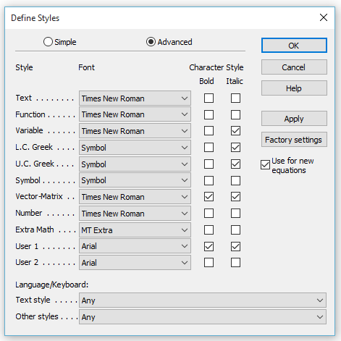
Tensor
Fig. 4 Equation styles
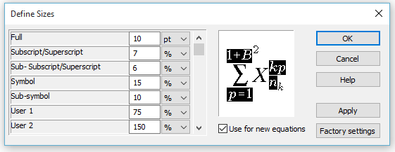
Fig. 5 Size of characters for equations
- Reference Format
Note the fact that several citations have been made in this document in order to illustrate their use. Number your references in your article sequentially in the order in which you cite them.
Respect recommendations of ISO 690 standard [14] in your reference section. Use the AiMT Reference style for your references – AiMT Reference style. This style will automatically number your references.

Tab. 1 Survey of the AiMT Journal styles
Paragraph Type | RAMS Style
Author line | AiMT Author
Abstract – text | AiMT Abstract Text
Acceptation information | AiMT Acceptation
Acknowledgement | AiMT Acknowledgement Text
Bulleted list | AiMT Bullet
Captions for Figures and Tables | AiMT Caption
Regular text with no first line indent (e.g. 1st paragraph of caption etc.). | AiMT Normal Continue
Equation numbers | AiMT Equation
Keywords – text | AiMT Keywords Text
Abstract – Heading | AiMT Abstract
Keyword – Heading | AiMT Keywords
Major (Level1) Section headings | AiMT Headings 1
Minor (Level 2) Section headings | AiMT Headings 2
Article Title | AiMT Title
Reference and Acknowledgement headings | AiMT Ref & Ack Headings
Reference entries in References section | AiMT Reference
Regular text | AiMT Normal
Figure | AiMT Figure
Affiliation | AiMT Affiliation

Acknowledgement
The work presented in this article has been supported by the Ministry of Defence of the Czech Republic (research project No. MO0FVT0000401).

References
The editors recommend the authors to use accessible information sources published in English and to prefer sources available online. References published in other languages may only be accepted in exceptional cases
  - Books and Similar Monographic Publications
Required information:
[Name of creator(s)]. [Title of the Book]. [Edition (required if the book is not a first edition)]. [Place of publication]: [Publisher], [Year of publication]. [Standard identifier (ISBN, ISSN or DOI)].
Examples of book citations:
- BLISCHKE, W.R. and D.P.N. MURTHY. Product Warranty Handbook. New York: CRC Press, 1995. ISBN 978-0-8247-8955-8.
- EBELING, C.E. An Introduction to Reliability and Maintainability Engineering. 3rd ed. Long Grove: Waveland Press, 2019. ISBN 978-1-4786-3734-9.
- BAUER, E. and A. RANDEE. Reliability and Availability of Cloud Computing. Hoboken: Wiley, 2012. DOI 10.1002/9781118393994.

  - Contribution within a Book or Similar Monographic Item (e.g. Conference Proceedings)
Required information:
[Name of creator(s)]. [Title of the contribution]. In: [Title of the book (proceedings)]. [Edition (required if the book is not a first edition)]. [Place of publication]: [Publisher], [Year of publication], [Range of page number(s)]. [Standard identifier (ISBN, ISSN or DOI)].
Examples of contribution citations:
- VALIŠ, D. and Z. VINTR. Development of Preventive and Corrective Maintenance Procedures Optimisation for Military Vehicles. In: Maintenance Modelling and Applications. Oslo: Det Norske Veritas, 2011, pp. 704-713. ISBN 978-82-515-0316-7.
- MAO, L.A., L.M. JACKSON, P. GOODALL and A. WEST. Enhanced Condition Monitoring of the Machining Process using Wavelet Packet Transform. In: D. THUAN, ed. Safety and Reliability – Safe Societies in a Changing World – Proceedings of ESREL 2018. London: CRC Press, 2018, pp. 1477-1484. DOI 10.1201/9781351174664.
  - Contribution within a Journal
Required information:
[Name of creator(s)]. [Title of the contribution]. [Title of the journal], [Year of publication], [Numeration – volume (number)], [Range of page number(s) or contribution identifier (number) – if available]. [Standard identifier (ISSN or DOI)].
Examples of contribution citations:
- STARÝ, V., V. KŘIVÁNEK, and A. ŠTEFEK. Optical Detection Methods for Laser Guided Unmanned Devices. Journal of Communications and Networks, 2018, 20(5), pp. 464-472. ISSN 1229-2370.
- MAZÁLEK, A., R. BEŠŤÁK, Z. VRÁNOVÁ and V. PLÁTĚNKA. Optimization of the Low-speed Link Throughput for Voice Services. Advances in Military Technology, 2017, 12(1), pp. 61-74. DOI 10.3849/aimt.01171.
- JÁNSKÝ, J., F. THOLIN, Z. BONAVENTURA and A. BOURDON. Simulation of the Discharge Propagation in a Capillary Tube in Air at Atmospheric Pressure. Journal of Physics D: Applied Physics. 2010, 43(39), 395201. DOI 10.1088/0022-3727/43/39/395201.
  - Online Publications
Required information:
The same information as for books or contributions within a book, proceedings or journal + information on availability and access.
Example of online book citation:
- STEVEN, W.S. The Scientist and Engineer’s Guide to Digital Signal Processing [online]. San Diego: California Technical Publishing, 1997 [viewed 2019-11-12]. Available from: http://www.dspguide.com

Examples of contribution in online journal:
- RUSEK, J. Application of Support Vector Machine in the Analysis of the Technical State of Development in the LGOM Mining Area. Maintenance and Reliability [online], 2017, 19(1), pp. 54-61 [viewed 2018-10-01]. ISSN 1507-2711. Available from: http://ein.org.pl/sites/default/files/2017-01-08.pdf
- LETTING, L., Y. HAMAM and A. ABU-MAHFOUZ. Estimation of Water Demand in Water Distribution Systems Using Particle Swarm Optimization. Water [online], 2017, 9(8) [viewed 2020-04-09]. DOI 10.3390/w9080593. Available from: http://www.mdpi.com/2073-4441/9/8/593

Example of contribution in conference proceedings:
- CU, X.P. and Z. VINTR. Reliability Estimation of Electronic Components by Step-Stress Accelerated Reliability Testing. In: 2019 International Conference on Information and Digital Technologies [online]. Žilina: IEEE, 2019, pp. 376-380 [viewed 2020-04-09]. DOI 10.1109/DT.2019.8813409. Available from: https://ieeexplore.ieee.org/document/8813409/
  - Standards
Required information:
[Identifier of the standard]: [Year of publication], [Title of the standard].
An example of standard citations:
- ISO 80000-1:2009, Quantities and Units – Part 1: General.
- ISO 80000-2:2019, Quantities and Units – Part 2: Mathematics.
- ISO 690:2010, Information and Documentation – Guidelines for Bibliographic References and Citations to Information Resources.

Notices:
If the title of a book (or a contribution) is not in English, the title translation should be presented in the citation with a note about original book language:
- ŠOBA, O., M. ŠIRŮČEK and R. PTÁČEK. Financial Mathematics in Practice (in Czech). Praha: Grada, 2017. ISBN 978-80-271-0250-1.

Even if the publication has more than 3 authors, all names should be given if possible. If any names are omitted, the name of the first creator shall be given followed by
“et al.”:
- VALIŠ, D., et al. Platinum Thermometer Failure Estimation Based on Dynamic Linear Models. Engineering Failure Analysis, 2019, 101, pp. 418-435. DOI 10.1016/j.engfailanal.2019.03.024. ISSN 1350-6307.

In the case of other types of citations see standard ISO 690 Information and documentation – Guidelines for bibliographic references and citations to information resources.

* Corresponding author: Department of Rockets, University of Defence in Brno, Kounicova 156/65, CZ-662 10 Brno, Czech Republic. Phone: +420 123 456 789, Fax: +420 987 654 321, E-mail: jan.novak@doma.cz. ORCID 0000-0000-0000-0000.

